ATIC Ex. 9

As a difference to the proposal, I do not consider velocity control anymore. The dynamics of the motor are too slow to be interesting. However, introducing a position state and implement line following would be interesting. This would be very similar to an inverted pendulum.

a)

i) Assumptions:

* Operating point was calculated and the system linearized around this point (see iv))
* Constant velocity. Dynamics of motor are slower.
* Coriolis force is neglected, since it small for small steering angles.
* Tires have infinite grip and follow exactly the steering direction.
* Linearization of angle mapping (highly optimistic). Linearization around the operating point.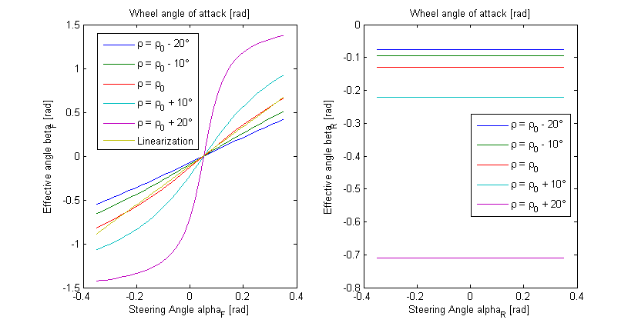  
  This graph depicts the resulting angle as a function of roll angle and steering input. The graphic below illustrates the geometry.  
  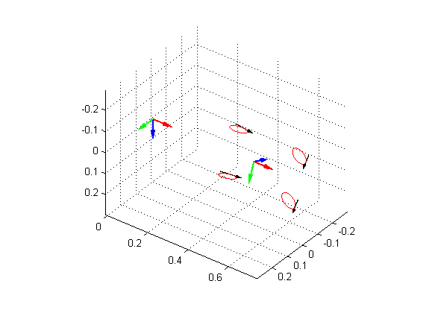

Ii / iii)

Uncertainty

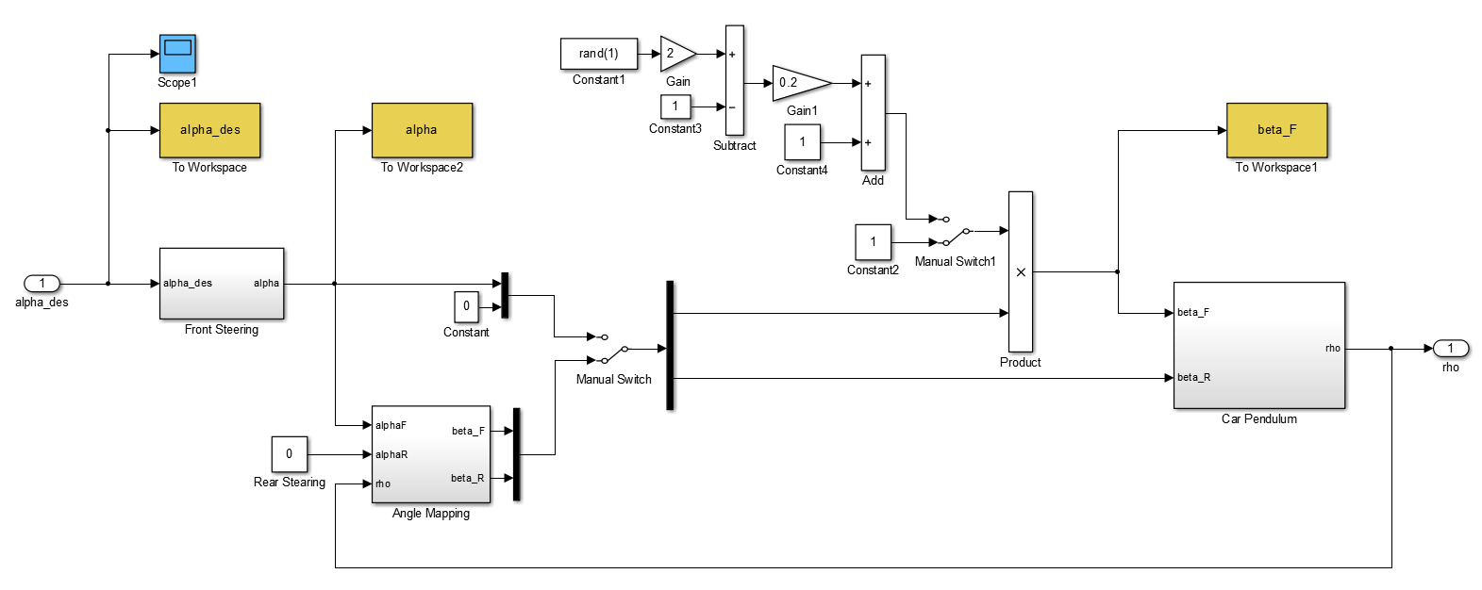

The perturbation is still included in the plant. I did not have the time yet to formulate it in the standard form since the modelling and integration took way more time than expected.

**Steering**

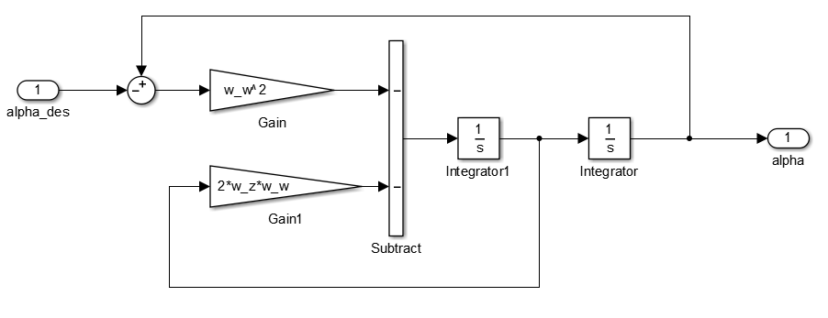

**1st order mapping of steering angle vs. effective angle**

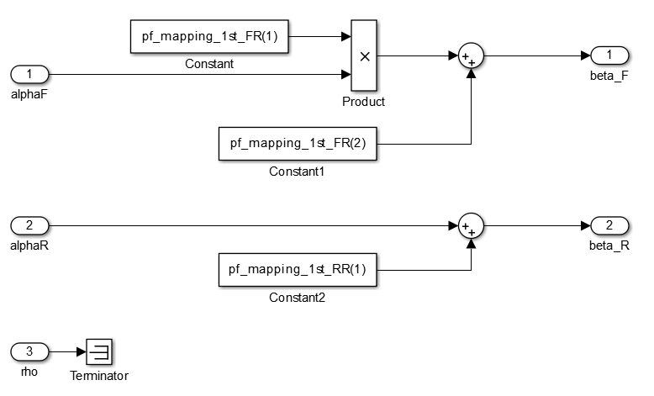

I’m thinking of implementing a 3D polyfit which also considers rho

**Car / Pendulum**

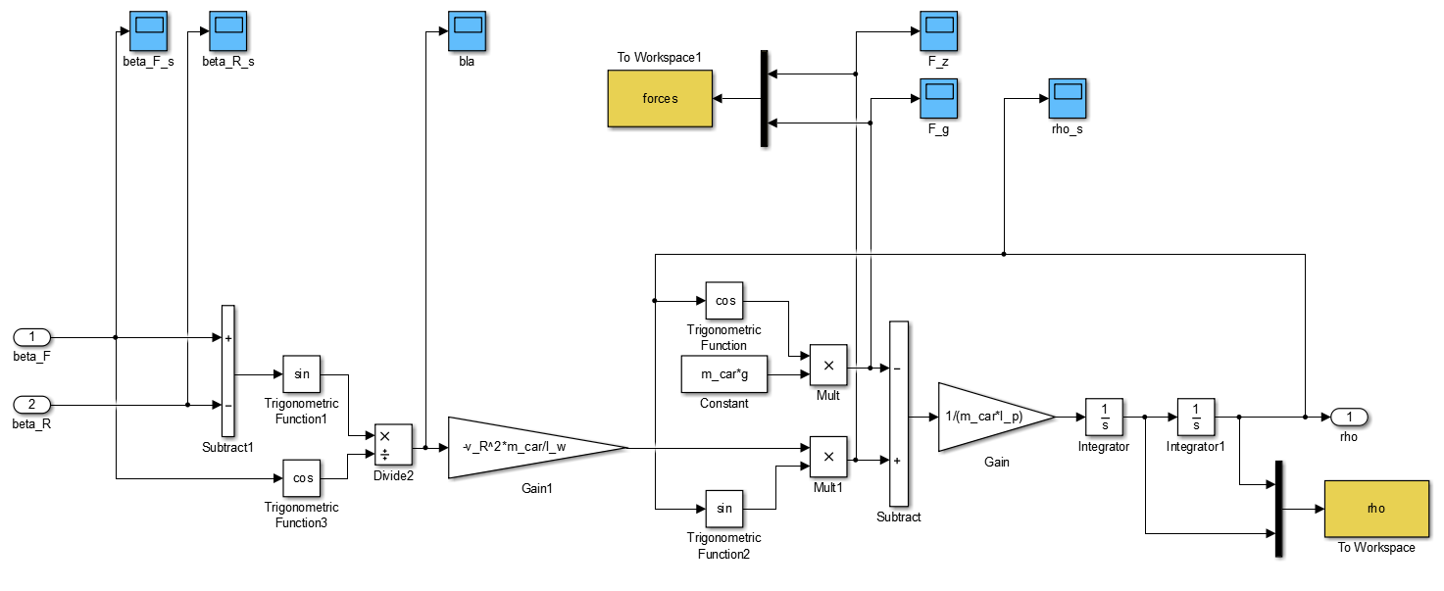

iv)

**States**

|  |  |  |  |
| --- | --- | --- | --- |
| Name | Description | Unit | Initial condition / Operating point |
| Phi | Angle of the pendulum | rad | Pi/2 |
| Phi_dot | Rate of above described | rad/s | 0 |
| Alpha | Angle of the steering mechanism (not equal to the effective angle on the ground) | rad | 0 |
| Alpha_dot | Rate of above described | rad/s | 0 |

**Inputs**

|  |  |  |  |
| --- | --- | --- | --- |
| Name | Description | Unit |  |
| Alpha_des | Desired steering angle | rad |  |

**Outputs**

|  |  |  |  |
| --- | --- | --- | --- |
| Name | Description | Unit |  |
| rho | Balancing angle of the car (inverted pendulum) | rad |  |

v)

**Sources of uncertainty:**

* Effective steering angle  
  Why: No tire model for slip, nonlinear  
  Could be up to +/- 100%
* Pendulum angle rho  
  Why: Noise, no accurate estimation  
  +/- 1 degree (should be conservative)
* Vehicle velocity  
  Why: Has an impact on centrifugal force (to the power of 2).   
  +/- 10%

b & c)

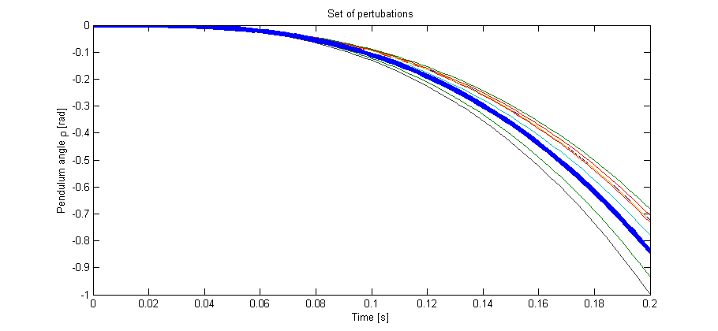

This plot shows step inputs on the system. The blue line is the nominal plant whereas the other lines are pertubated systems. Since the system is open-loop unstable, just 0.2 seconds are shown.

The car is expected to drive on the right wheels. A positive input to the steering (alpha) is equivalent to turning the car to the right side. This leads to a centrifugal force which pushes the car to the ground and hence decreases the pendulum angle rho.

The uncertainty is chosen to be +/-20% on the effective steering angle of the front wheel. This is motivated through the delay of the steering actuation as well as unmodelled influence of the tires.

The system response makes sense sense so far.

Equations and drawings:

